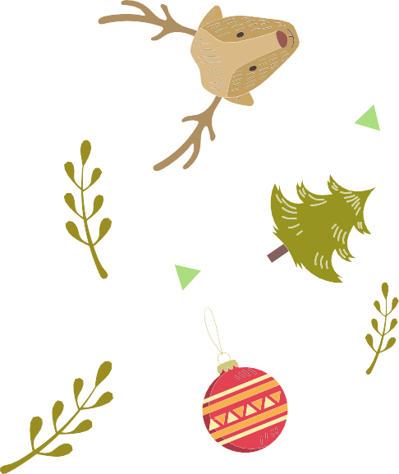
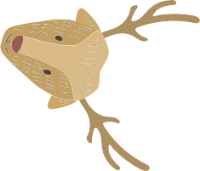
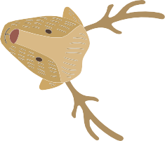
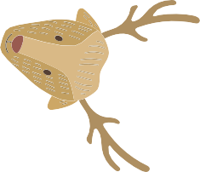
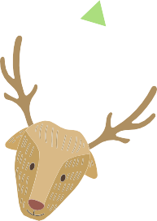
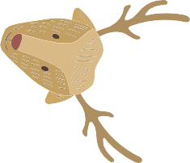
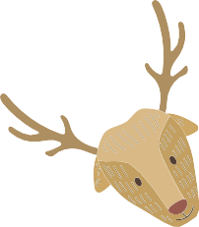
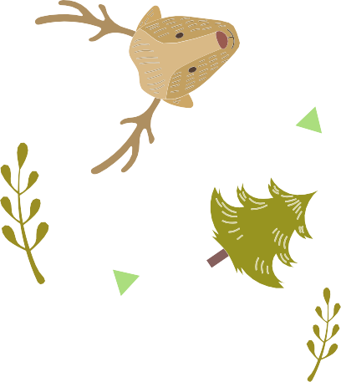
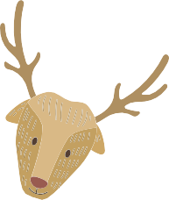
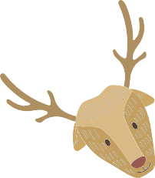
Task 1. Solve the crossword puzzle to find out the title of one of the most popular Christmas songs (12 points)
1. The feeling of happiness, pleasure and delight, typical for Christmas.
2. A present (synonym).
3. A special sweet food that contains a lot of dried fruit. Families in Britain have it on Christmas Day for the dessert.
4. A long sock which children leave in their house on Christmas Eve and find presents in it.
5. A dark green plant with white berries. If you are caught under it at Christmas, you will probably get a kiss.
6. Decoration for Christmas tree.
7. Girls tie their hair with it, you can also use it to wrap presents.
8. One of 9 animals which pull Santa Claus’ sleigh.
9. A plant with sharp dark green leaves and red berries, a decoration at Christmas.
10. A traditional Christmas song.
11. People send millions of them before Christmas.
12. What is one of the most popular Christmas songs?
12
1.
2.
3.
4.
5.
6.
7.
8.
9.
10.
11.
Task 2. Complete this paragraph using the words below. Write the words in the spaces. (8 points)
Christmas is a time of _______________. There have been festivals for about 4000 years in _____________. Christmas ____________ are a sign of Christmas. The trees look pretty with nice ___________ under them. Children wait for _____________ to come. On Christmas day we eat __________ and other good things. We pull ___________ with ___________hats, small presents and jokes inside.

Task 3. Put the verbs in brackets in the right tense form (12 points).
Preparing for Christmas!

Santa Claus 1. (be) very busy last week. He 2. (prepare) lots of toys for all the girls and boys in the whole world all day long. Yesterday he 3. (read) every letter carefully. Then he 4. (gather) his hardworking elves in his neat and comfortable workshop. There they 5. (plan) out well the work to be 6. (carry) out. The elves 7. (work) hard. They 8. (make) such lovely toys. While everyone 9. (work) hard, Santa 10. (feed) the reindeer. Each toy 11. (have) a name on it: Dasher, Dancer, Prancer, Vixen, Comet, Cupid, Donner, Blitzen and Rudolf.

Task 4. Make up adjectives from the following nouns and fill in the gaps with them.

joy | Have a |  |  |  | Christmas day!
peace | Have a |  |  |  | Christmas!
wonder | We hope the children have |  |  |  |  |  | behaviour at Christmas!
religion | Christmas Day is a |  |  |  |  |  | holiday celebrating the birth
 | of Jesus Christ.
frost | It was a white, |  |  |  |  | Christmas night.

Task 5. Are you good at translating poems?
Try to translate a poem. Write it down in Russian. Don`t forget about the Rhyme.

I wish that dear old Santa
Would take me for a ride;
I'd like to drive his reindeer
And sit by Santa's side.
I'd like to help old Santa
Find all the girls and boys,
So each one might be happy
With Christmas books and toys.

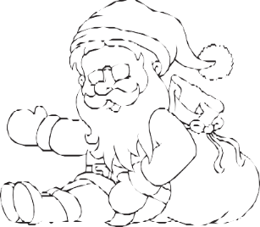
Task 6. CHRISTMAS WORD SCRAMBLE
Unscramble the following Christmas words use the back of this paper to write a sentence for each word.

E S G C O R O
C I O N L A R G
A S T R

S T E S T U N H C

D O H R U L P

T N S A A

E N S R M T N O A

S H E R D E H P

1.
2.
3.
4.
5.
6.
7.
8.
